**Modern Bedroom Shelves**

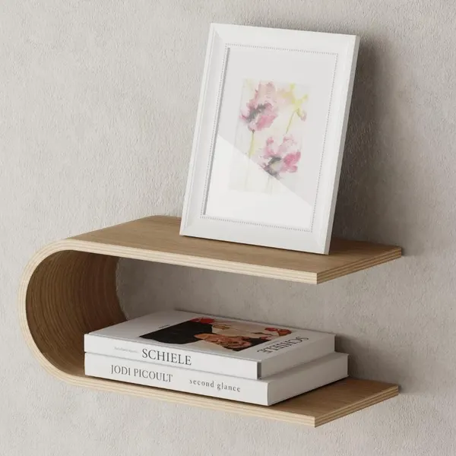 Modern Bedroom Shelves are sleek, functional, and stylish pieces of furniture that can enhance the design and organization of any bedroom. With clean lines, minimalist aesthetics, and a variety of materials such as wood, metal, or glass, these shelves help to create a clutter-free space while adding visual interest. Whether installed on the wall as floating shelves or incorporated into a larger storage unit, modern bedroom shelves are perfect for displaying books, plants, photos, or small decorative objects. Their versatile design complements various bedroom styles, from contemporary to industrial, offering both practicality and a refined look to your sleeping space.